**Operation Guide for HUAWEI Uniportal Registration**

1. If you do not have a Uniportal account, click the following link to register: <https://uniportal.huawei.com/accounts1/register-pc.html?lang=en_US&redirect=https%3A%2F%2Fe.huawei.com%2Fen%2Ftalent%2F%23%2FoperationCenter>.

Enter information as prompted, and submit the information as shown in the following figure.

【Note】

* Please select your exam country/region.
* Please input your email address to register.

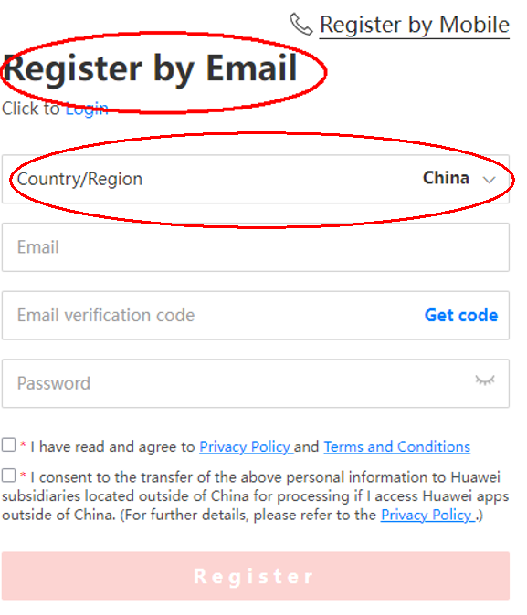

1. Enter your email address and verification code:

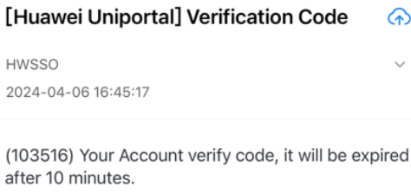

1. Fill in the account name, password and agree to the statement, click [Register]

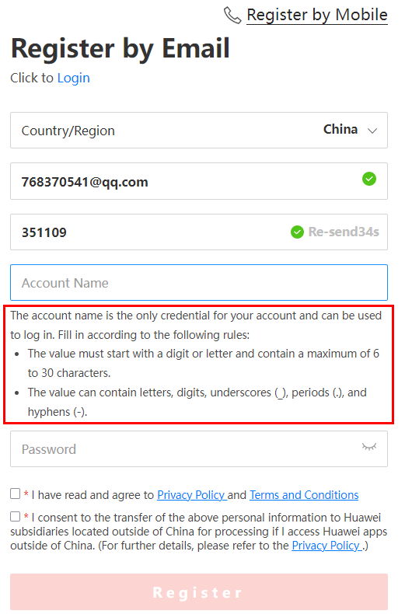

1. Account-related FAQ:

<https://uniportal.huawei.com/uniportal1/help.html?lang=zh_CN&redirect=https%3A%2F%2Fe.huawei.com%2Fcn%2Ftalent%2Fusercenter%2F%23%2Fhome>

If you have any other questions, submit a case at the following link:

[https://e.huawei.com/en/talent/#/issue/add](https://e.huawei.com/en/talent/%23/issue/add)

1. Log in to Huawei Talent Online and view the account information:

